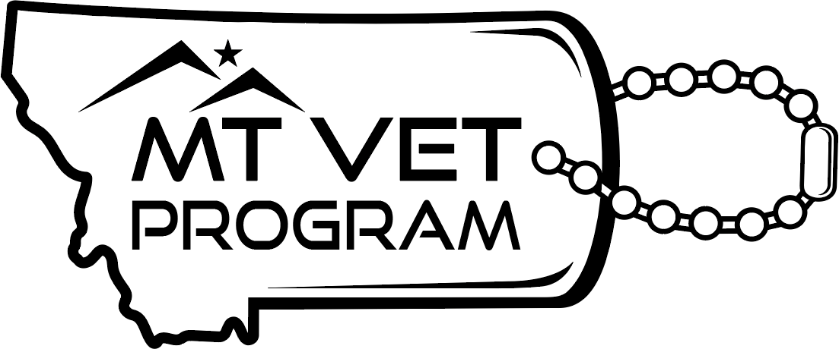
To the individuals participating in the Montana Vet Program’s Bob Marshall Wilderness Veteran Led Therapeutic Adventure Trip (VLTAT 25-4), I would like to say thank you for your time, participation, and future suffering. We believe Montana can heal its veterans.

Mission:
Using MVP gear, we will hike our fallen brothers and sisters “MVP’s Pig Egg” through the Bob Marshall Wilderness, while taking time to appreciate the therapeutic aspects of Montana’s iconic locations.

Lodging:
All participants will arrive in Great Falls Wed September 3rd, those traveling from out of town will be provided hotel accommodations for that night. From September 4th through September 7th, lodging will be provided by the Montana Wilderness. The night of September 7th those needing a hotel will be provided one.

Food:
MVP will be providing the food for this trip. Our food plan will consist of freeze- dried meals, granola, mountain stew, electrolytes, and a snack bag. If there are small food amenities, you would like to bring feel free. Additionally, while on this trip there will be no alcohol. If you suffer from any food allergies or have any special food considerations we should know about, LET US KNOW! Once off the mountain, there will be opportunities to stop and purchase food and drinks- don’t forget your wallet.
Our Cannabis policy : Don't Ask Don’t Tell. If you use cannabis for medicinal purposes, feel free to use it. We only ask that you keep it discreet.

Equipment:
MVP will be providing the equipment, to include packs, sleeping bags, tents, etc., see full list at the bottom. We will not provide shirts, pants, shorts, socks, shoes, hats, knives, sunglasses, or hygiene equipment (hygiene gear is not an option, please bring). If you wish to bring small pieces of gear specific to you and your needs feel free, however, it is our goal to provide all participants with all mission essential gear. Again, if there are any special considerations or special equipment you need, please let us know. Important: We ask that participants not bring their personal firearms on our trip. As a safety precaution for wildlife, participants will be issued a can of bear spray and an MVP team leader will carry a firearm.

Transportation:
Transportation to and from our insert and extract points will be provided by
MVP.

From there we will move approximately 40 miles over the next four days to our
vehicles.

While we are hiking our vehicles will be shuttled by volunteers. Drive time from our meeting point to trail-head is approx. 5 hours, and our return time is approx. 5 hours as well. Driving to and from each location we will be passing through small towns and will be able to make rest stops as needed.

Hike: Our intention is to hike roughly 10 miles per day for four days. We will travel along a water source for 90% of our route.

Medical: Each participant will be issued their own first aid medical kit.

Special equipment:
We will have a Garmin in Reach with us in case of emergencies, as well as our multiple first aid kits.

Filming:
Be prepared to be filmed during our trip. Your smiling faces will hopefully help other veterans come experience what you are.

Weather:
We will brief the weather as we get closer to our insert date. Wildfires are always a possibility, so we may have to change our destination at the last minute.

Special gear for participants to bring:
Sunglasses, Chap Stick, sunscreen, pocketknife, lighter, hat, pocket notebook and pen or pencil, flip-flops, or lightweight camp shoe (Crocs) for water crossings or lounging at camp.

Talking points upon arrival:
- Participant specific medical issues/medications. Notify team leaders.
- Concerns, treatment, and dealings with animals: (rattlesnakes, cattle, coyotes, etc.)
- Conservation (what is our role while in the Montana wilderness)
- Human waste measures at primitive camp sites

Issued Gear:
Participant Gear:
Osprey Vol 75L/Stone Glacier 6400 Mountain Hardware, Stone Glacier (Sleeping Bag) Nemo inflatable sleeping pad
Black Diamond, Trekking poles GSI, Glacier Stainless Cup
Sea to Summit, Alphalight Long Spork

Black Diamond, Spot headlamp Suunto , A-10 Compass
AMK, Ultralight .9 Medical Kit SOL, Escape Bivy
Nalgene 32 oz (X2) BearVault, BV500 (bear bag)
Frog Toggs, (Rain Gear top & bottom)
Sea to Summit, Lightweight Dry Sack 35 L Sea to Summit, Lightweight Dry Sack 13 L Sea to Summit, lightweight Dry Sack 2 L Bear Spray

Team Gear:
Big Agnes, Copper Spur HV UL4 (Tent)
Katadyn, Gravity Camp 6L (Water filtration system) MSR, Whisperlite Unversal (Stove)
GSI, Halulite 1.8L Boiler (Pot with Fuel)

